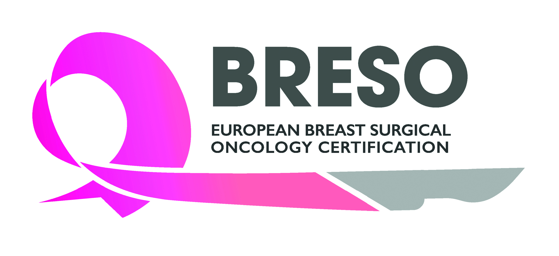

BRESO Certification Application (Retrospective)
This application is to be completed by senior surgeons with more than 5 years’ experience at consultant/attending level. Trainees and recently qualified breast surgeons (within 5 years of completion of training) should however apply for prospective certification. For more information, visit https://breastsurgeoncertification.com/prospective-certification/ or send an e-mail to: info@breastsurgeoncertification.com.

Your details:

Title
Family name
First name
Date of birth
Institute
Department
Position
Address
Postal code
Town
Country
Phone number
e-mail

Member of | European School of Oncology (ESO)  European Society of Surgical Oncology (ESSO)  European Society of Breast Cancer Specialists (EUSOMA)  European Breast Cancer Research Association of Surgical Trialists (EUBREAST)  Group for Reconstructive and Therapeutic Advancements (G.Re.T.A.)  Other:  Other:  Other:  Other:

Specialty | General Surgery  Gynaecology  Plastic Surgery  Other:

- Please describe your medical education*: full medical qualification and active licence to practice (in good standing, surgeons under suspension will not be eligible) and completion of surgical training in general, gynaecology or plastic surgery

Institution | Year / period (from ... to ...) | Degree
*Please provide medical degree, licence to practice and completion of training certificates if available or other form of evidence such as current licence to practice certificate if not. These are acceptable untranslated IF in a European language, but if not, an English Language translation must be provided.

- Please describe here your experience as a senior/attending/consultant surgeon in a specialist breast unit (at least 5 years experience, treating a minimum of 150 cases per year for at least 2 of the previous 5 years and personally treating a minimum of 50 cases per year for all of the previous 5 years)*. Practice may be in a public or private hospital or a combination of the two. Practice must be breast focussed for at least 50% of your working hours.

Institution | Year / period (from ... to ...) | Degree
* Please provide CV plus letter from head of Department or, if you are HOD, letter from the hospital medical director or senior colleague or print out from the hospital computerized system to confirm these standards.

- Please describe here your most important published scientific papers related to breast surgery: minimum of 3 pubmed listed publications over the entire career AND documentary evidence of either: one completed audit or service evaluation of local unit practice, academic presentation (oral or poster) or engagement with service improvement and a good understanding or evidence-based practice*
Year / period | Description
*Please provide copies of publication PDFs, evidence of presentations (published abstract, poster PDF, letter of acceptance, congress schedule) or local audit/service evaluation reports

- ONGOING PROFESSIONAL TRAINING/EDUCATION

I have attended the following international courses or conferences (at least 1 breast congress or course per year of which 2 must be international, such as EBCC, St Gallen, San Antonio, Breastanbul, in the previous 5 years). Congress may be virtual*

 | Year | Yes | No
EBCC Congress
ESSO Breast Course
ESSO Oncoplastic Course
ESO-ESMO BCY (Breast Cancer in Young Women conference)
St Gallen Congress
San Antonio Conference
Breastanbul
*Please provide a copy of at least 2 certificates of attendance

- I hereby confirm that I attend properly constituted breast MDT* on a weekly basis i.e. with attendance of a medical and radiation oncologist, pathologist and imaging consultant, and with at least 50% attendance.

*Group of dedicated breast cancer specialists working together as a multidisciplinary team (MDT) with access to all the facilities required to deliver high-quality care throughout the breast cancer pathway. Breast core MDT members are breast specialists who are essential for diagnosis and care of breast cancer, who spend the majority of their working time in breast cancer (Ref: The requirements of a specialist breast centre, The Breast, Volume 51, P65-84, June 01, 2020. Open Access Published: March 24, 2020 DOI: https://doi.org/10.1016/j.breast.2020.02.003)

Please provide a letter from the Head of Department or, if you are Head of Department yourself, letter from the hospital medical director or senior colleague to confirm this

- LOGBOOK

I hereby confirm a minimum of 30 ANCs, 100 SLNB, 50 Mx, 150 BCS and 20 oncoplastic cases over the last 5 years.

Ideally please provide a log book summary or a letter from the Head of Department to confirm indicative numbers achieved, or a print out from the hospital computerized system for at least 1 of the last 5 years.

- KNOWLEDGE

I have taken and passed the UEMS European Board of Surgery Qualification (EBSQ) in Breast Surgery exam in breast cancer surgery* or another examination certifying my expertise in breast surgery (honorary certification is acceptable)
 | Year | Yes | No
EBSQ examination in Breast Surgery
Other certificate of competence:
* Please provide a copy of the UEMS certificate (FEBS), FRCS (breast interest), UEA MSc, ESO Certificate of competence in breast care. Others may be permitted on review of course content.
OR

I confirm advanced level competency in the management of breast cancer, including Oncoplastic techniques (BRESO acknowledges that breast examinations are a recent development)
* Please provide a testimonial from the Head of Department or, if you are Head of Department yourself, a letter from the hospital medical director or a senior colleague

Additional comments:

Please send back your completed application form together with all relevant documentation to the BRESO Secretariat at info@breastsurgeoncertification.com (with cc to carine.lecoq@essoweb.org).
Your application will be reviewed by the BRESO retrospective certification working group.

Please note that an administrative fee of 200 EUR will be charged to contribute to the BRESO Foundation and its administration.

