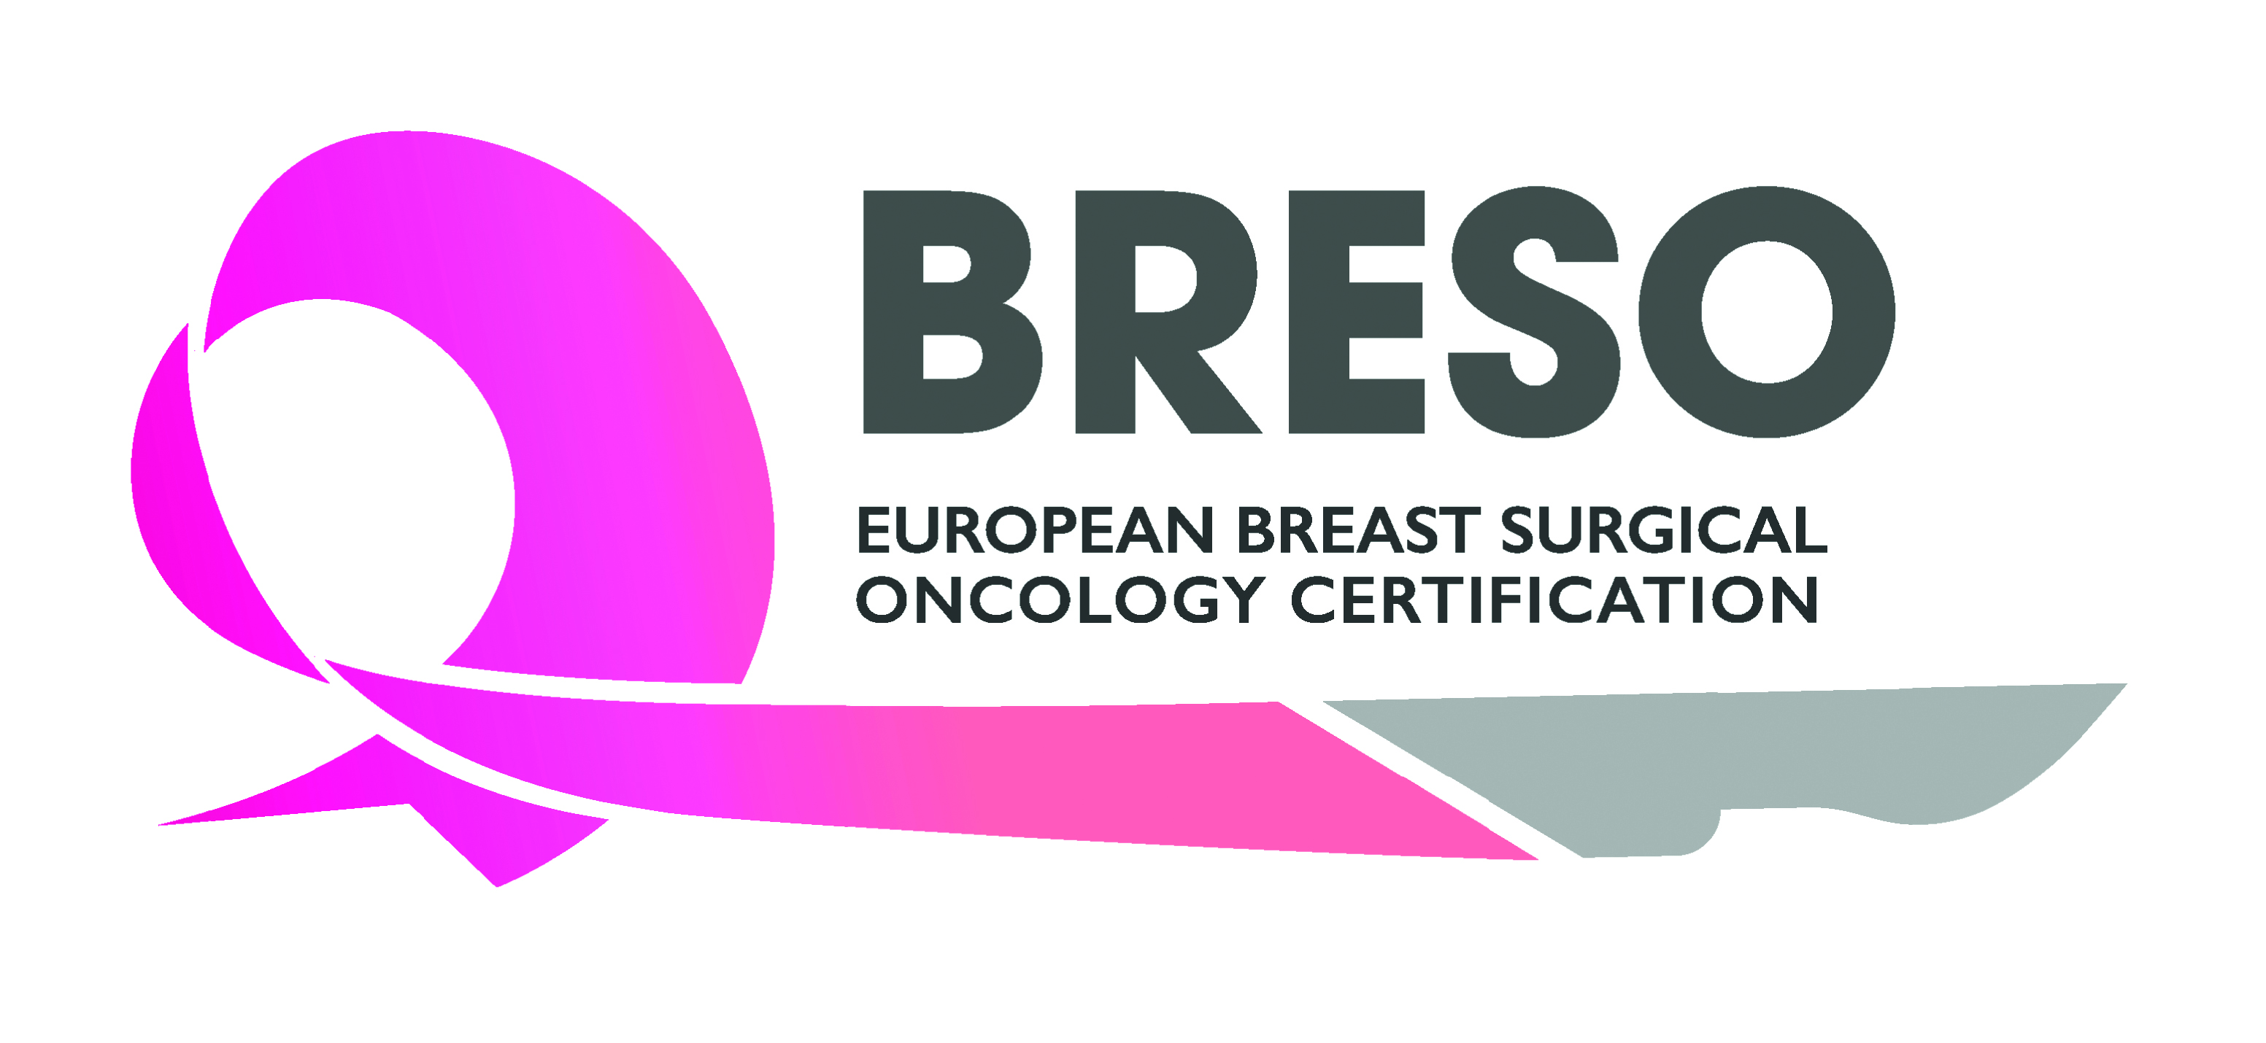

BRESO Certification

Training Programme Application

Your details:

Title
Family name
First name
Date of birth
Institute
Department
Address
Zip code
Town
Country
Phone number
e-mail

Member of | ESO  ESSO  EUSOMA  EUBREAST  G.Re.T.A.  Other:

Specialty | General Surgery  Gynaecology  Other:

Please describe your undergraduate and postgraduate medical education
*Medical Degree (please provide certified copies of the relevant certificates translated in English if not in English originally)

Institution | Year / period (from ... to ...) | Degree

Please describe your motivation for participating in this training programme

PRACTICAL TRAINING

Have you already chosen a training fellowship in a breast unit?

Yes No

If yes, please list here the breast unit(s) you wish to visit. The BRESO Board will evaluate if the outlined centre(s) meet the criteria to accomplish the training programme.

* Please note that the institute where the training programme will be carried out must be BRESO approved. If this is not yet the case, please ask the institute to apply for being a recognized BRESO training center via this link: https://breastsurgeoncertification.com/breast-units-requirement/

Institution | Dates | Mentor name and contact details

Additional comments:

Please send your application to the BRESO Secretariat at info@breastsurgeoncertification.com accompanied by the following documents (all documents should be renamed in pdf format):

- Curriculum vitae
- Board certification in general surgery or gynaecology in your country
- License to practice as a general surgeon, and/or gynaecologist in the country where the training fellowship will take place
- Letter of interest from the candidate regarding breast cancer training and academic interests
- Letter(s) of recommendation from your head of Department and/or mentor
- Documentary proof of identification such as a passport or National identity card

